JDA Security Roles

SRD Team
Ott Rojanava
Eric Metz

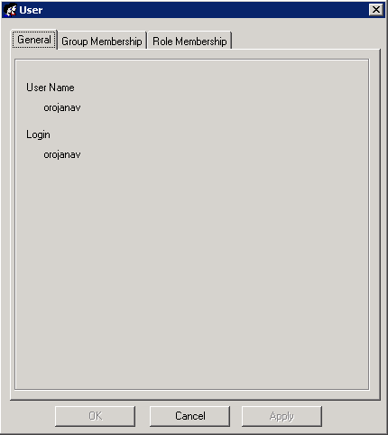 | Create the user ID
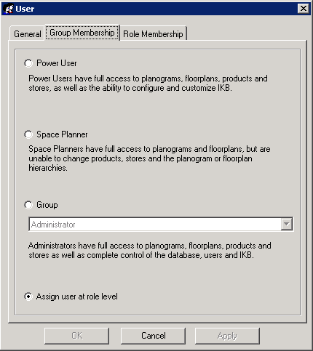 | Select Assign user at Role Level
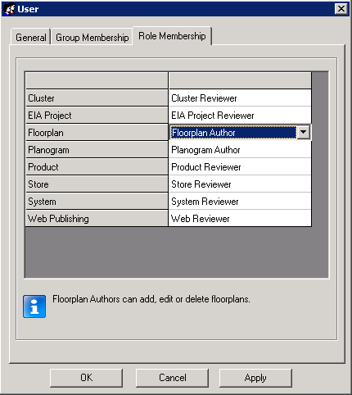 | Planogram – Author  Floorplan – Author
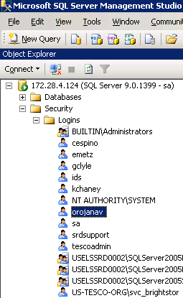 | To edit the Security credentials, access directly to the SQL server will be required.  Locate the user ID that was created.  Right click the user ID and select Properties
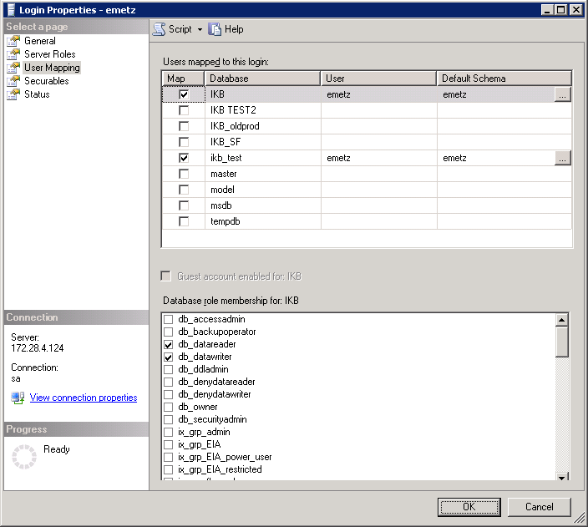 | The following window will show more user credentials.  The following needs to be selected:  Database Role Membership for IKB  Per JDA Carla Goodwin, by default these should be selected  Db_datareader  Db_datawriter
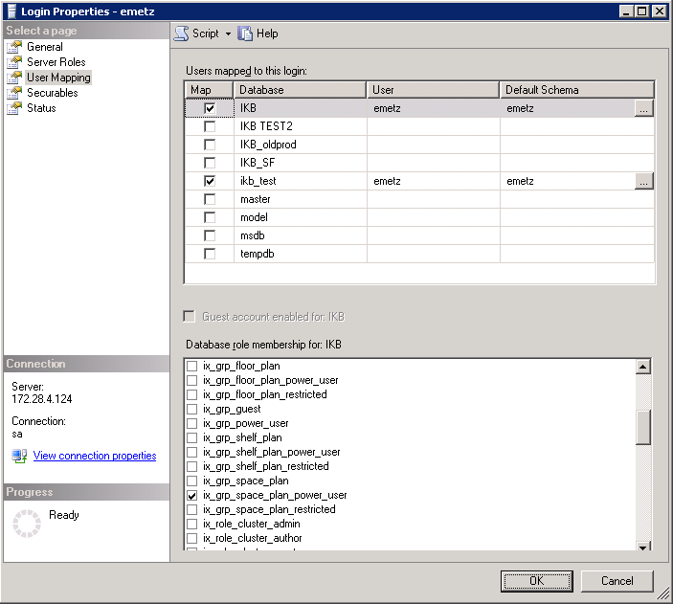 | Ix_grp_space_plan_power_user  By selecting this the user can manually change the lifecycle of a POG from WIP – ASO – SO  The default security setup for the user did not have the option to change lifecycles for a POG.
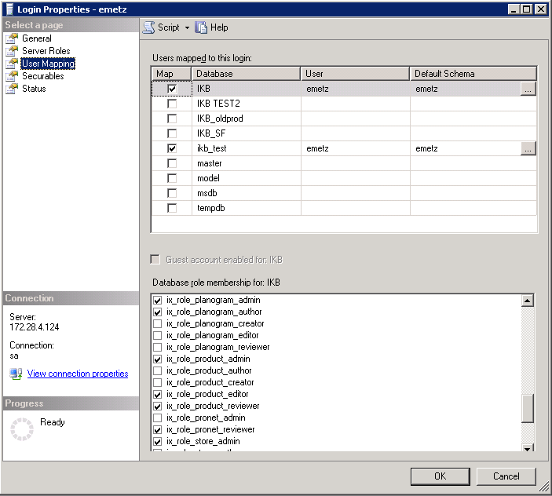 | Ix_role_product_editor  User can update the Product dimensions

